**Level 1: PC Tower Case**

**Outline**

Learn about the internals of a standard PC case by examining physical samples and selecting and labeling images found on-line. Gain deeper knowledge by researching and reporting on specific components.

**Questions**

1. Find one (or more) images that clearly show the internals of a PC Tower Case.   
   (i.e. Google images using keywords “PC Case Internals”)
2. Clearly label the following components (using arrows) on your image of the PC case internals:
   1. Motherboard
   2. Power Supply
   3. Hard Disk Drive
   4. Optical Disk Drive (e.g.DVD)
   5. USB Expansion Ports
   6. Monitor Port
   7. Audio Ports
   8. Ethernet Port
   9. Cooling Fan

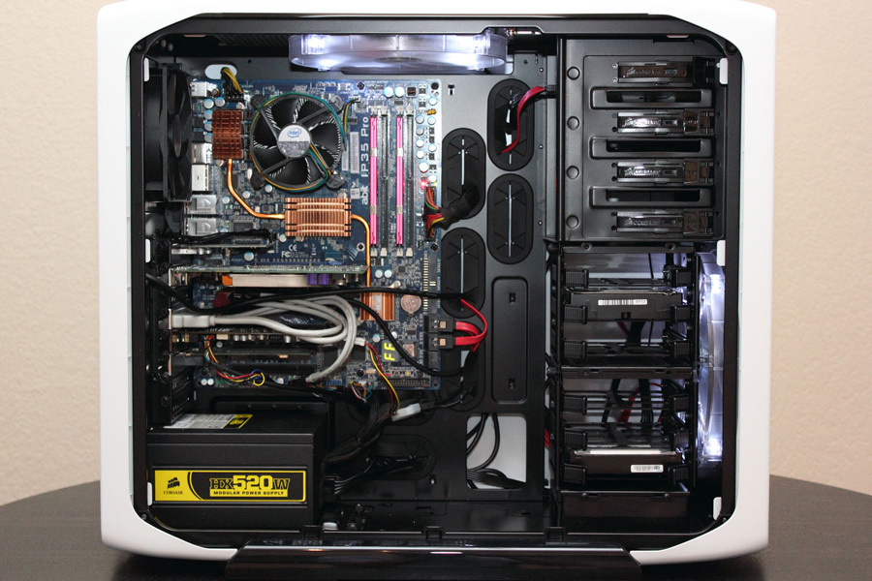

1. Research more in-depth about “Motherboards”. Make notes on the following:
   1. What different versions are currently available (speed and capacity)
   2. How the component has changed since the 1980’s

Each board stick maximum is around 16gb which is 16 times 4=64gb per a computer.

In the 1980’s there was only mb and rarely would be gb.

1. Research more in-depth about “Hard Disk Drives”. Make notes on the following:
   1. What different versions are currently available (speed and capacity)
   2. How the component has changed since the 1980’s

Hard disks maximum capacity is 8 tb in nowadays with a really good computer.

In the 1980’s the maximum capacity was in the gb’s.

**Level 2: PC Motherboard**

**Outline**

Learn about the structure of a standard PC motherboard by examining physical samples and selecting and labeling images found on-line. Gain deeper knowledge by researching and reporting on specific components.

**Questions**

1. Find one (or more) images that clearly show the layout of a PC Motherboard.   
   (i.e. Google images using keywords “PC Motherboard”)
2. Clearly label the following components (using arrows) on your image of the PC motherboard:
   1. CPU (and fan)
   2. RAM Memory
   3. Disk Drive Interface (IDE or SATA)
   4. GPU Graphics Processor (either on-board or Graphics Card)
   5. Sound Processor (either on-board or Sound Card)
   6. Wi-Fi / Ethernet Network Interface (either on-board or Graphics Card)

1. Research more in-depth about “CPU Processor Chip”. Make notes on the following:
   1. What different versions are currently available (speed and capacity)
   2. How the component has changed since the 1980’s  
      CPU stands for computer processor chip and its main task is to run all the main tasks in the computer.

The component has changed as now the chip is way faster than the ones that were used in the 1980’s.

1. Research more in-depth about “RAM Memory”. Make notes on the following:
   1. What different versions are currently available (speed and capacity)
   2. How the component has changed since the 1980’s  
      The maximum capacity of ram is about 16 gb and the speed is it can transfer 8gb per a second.

The maximum capacity was way lower and speed was way lower as well.

**Level 3: Peripheral Devices**

**Outline**

Learn about how peripheral devices are connected to the back side of a typical PC tower case. Examine physical samples, select and labeling images found on-line and gain deeper knowledge by researching and reporting on specific components.

**Questions**

1. Find one (or more) images that clearly show the layout of the back of a typical PC tower case.   
   (i.e. Google images using keywords “Back Of PC Tower”)
2. Clearly label the following components (using arrows) on your image of the back of a typical PC tower case:
   1. Power cord and power switch

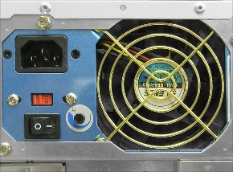

* 1. Monitor Interface (VGA or DVI or HDMI)

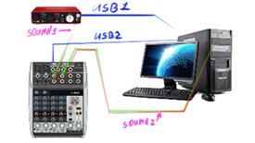

* 1. Mouse Interface (USB or PS/2)

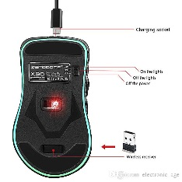

* 1. Keyboard Interface (USB or PS/2)

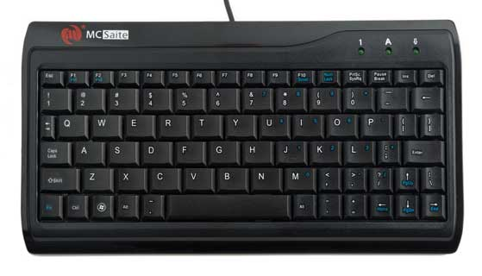

* 1. USB Ports

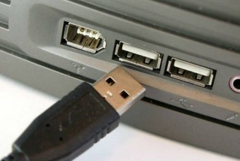

* 1. Audio Inputs / Outputs

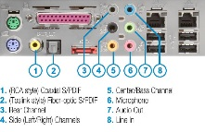

* 1. Ethernet Interface

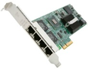

1. Research more in-depth about “Monitor Technology”. Make notes on the following:
   1. What different versions are currently available (e.g. VGA / DVI, Flat Panel Technology))
   2. How the component has changed since the 1980’s (e.g. Display Resolution, Technology)  
      a. Panel technologies are the overwhelming majority of computer monitors, laptop screens and tablets are based on TFT-LCD.

b. Electrically operated display devices have developed from electromechanical systems for display of text, up to all-electronic devices capable of full-motion 3D color graphic displays. One of the earliest electronic displays is the cathode ray tube (CRT), which was first demonstrated in 1897 and made commercial in 1922.

1. Research more in-depth about “External Portable Storage”. Make notes on the following:
   1. Floppy Disks

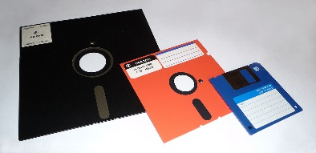

* 1. CD-ROM / DVD / Recordable CD/DVD

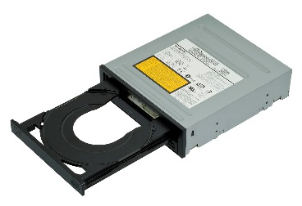

* 1. USB Memory Drives

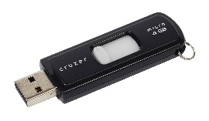

* 1. Compact Flash Memory

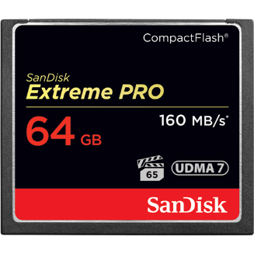

* 1. Cloud Based Storage

